**Task 1. Launch an EC2 Instance:**

* 1. **Launch a new EC2 instance using the Amazon Linux 2 AMI using AWS console.**
  2. **Configure Security Group:**
     1. **With 22 and 80 Ports open.**
  3. **Connect to EC2 Instance:**
     1. **Connect to the newly launched EC2 instance using SSH.**

**Steps to launch an EC2 Instance using the Amazon Linux 2:**

1. In AWS console home search for EC2 and navigate to the EC2 console.

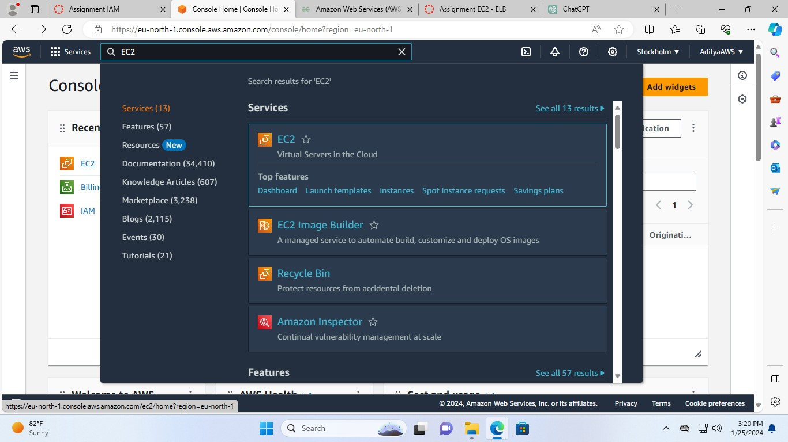

1. Click on the Launch instance

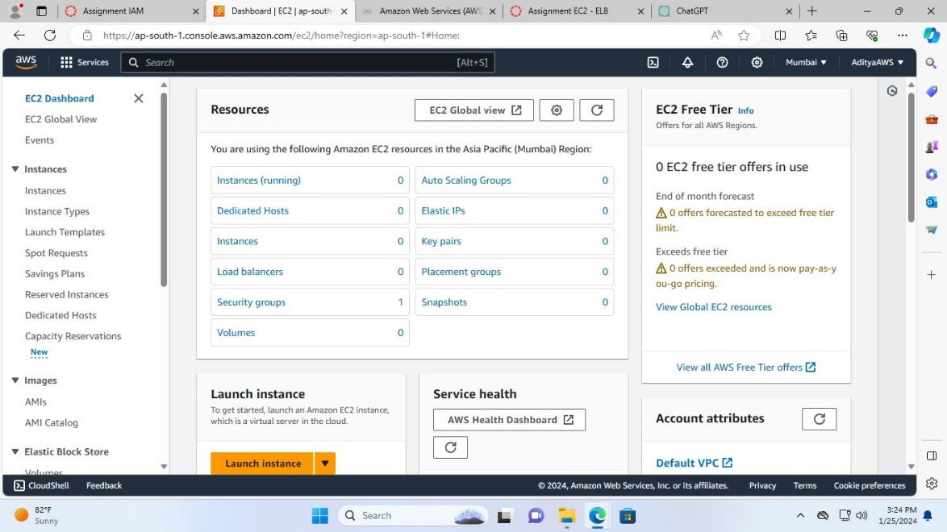

1. Name the instance as I have named it Linux AWS.

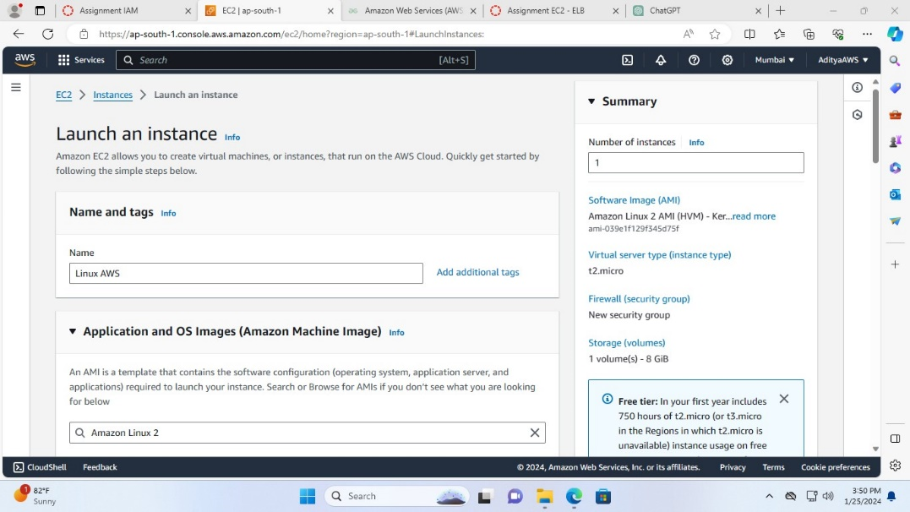

1. Then search for the Amazon Linux 2 in the AMI section and select the Amazon Linux 2 AMI with the latest version.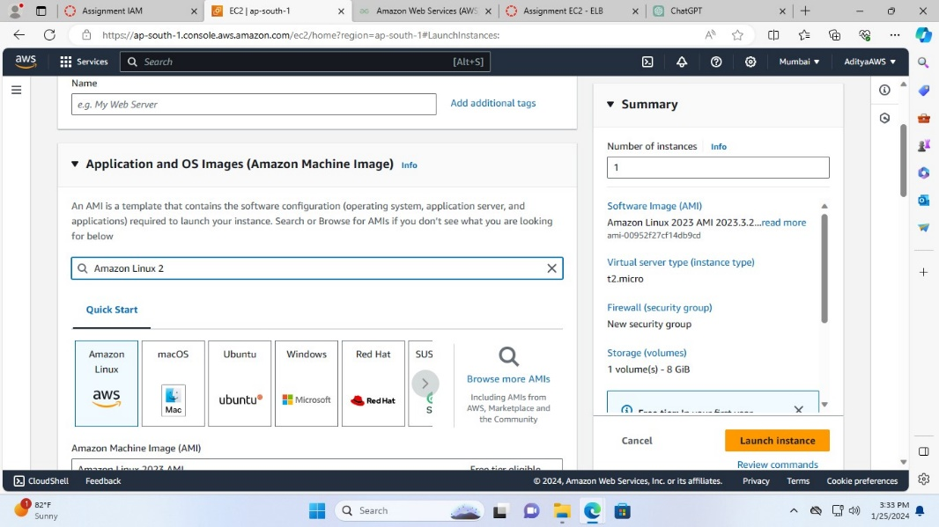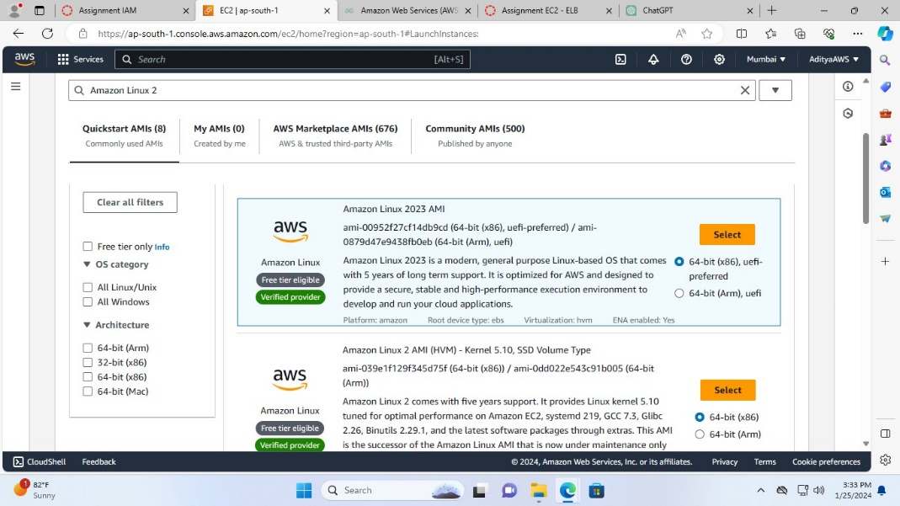

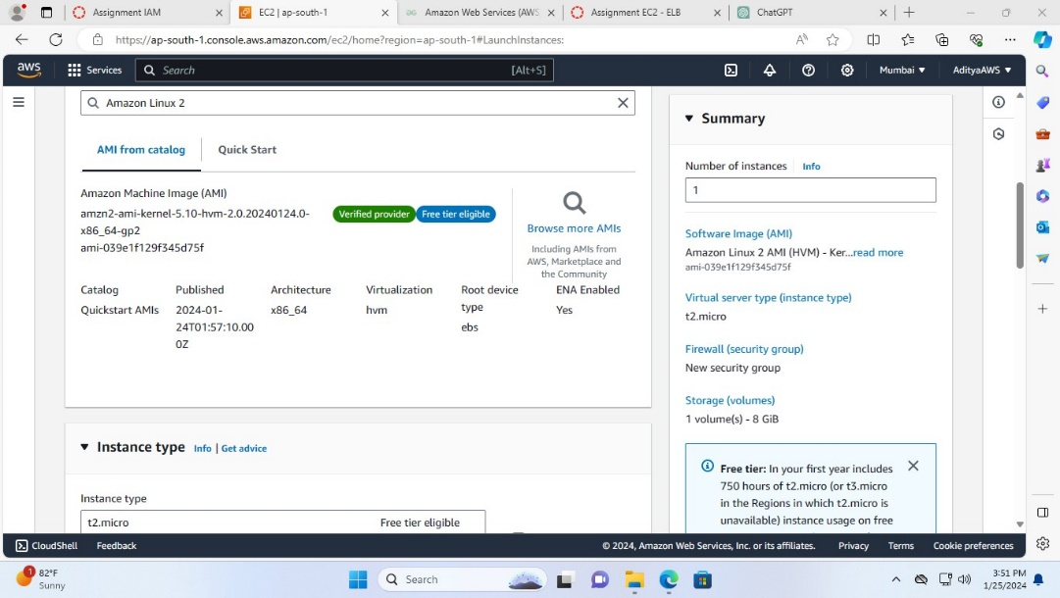

1. Choose the instance type t2.micro and in the key pair section click on create new key pair.

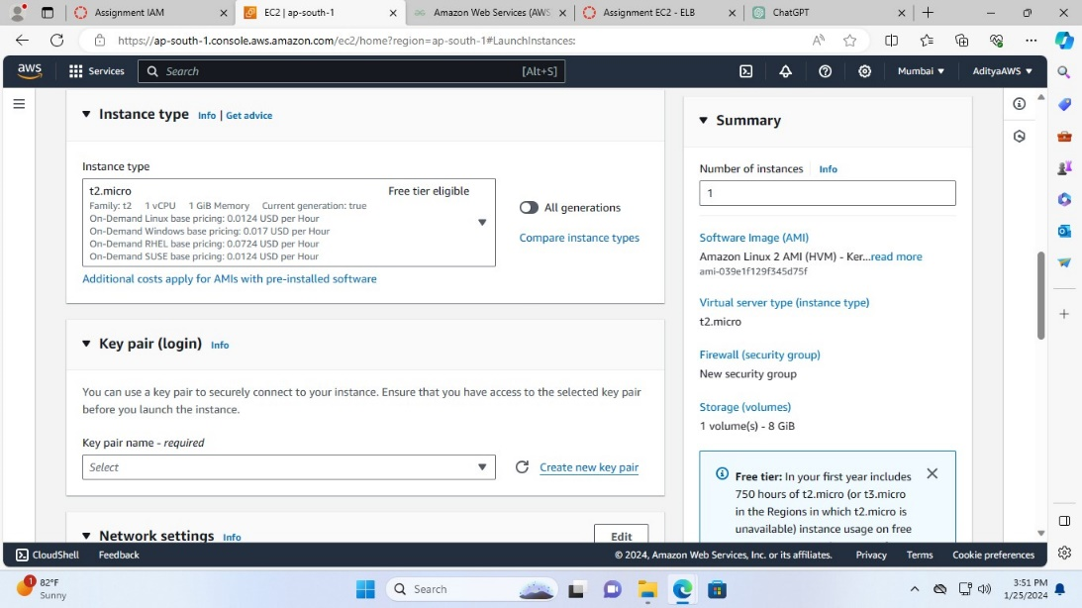

1. Name the key pair, leave the other sections as it is and click on Create key pair.

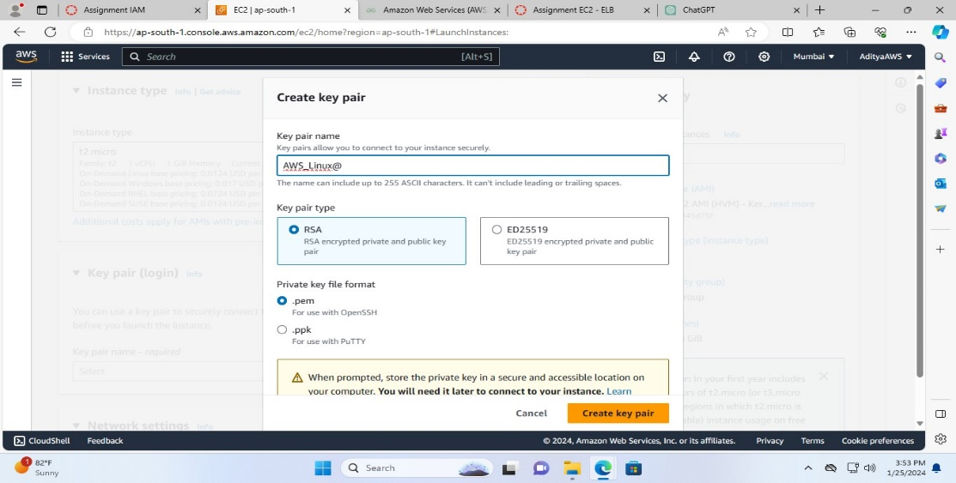

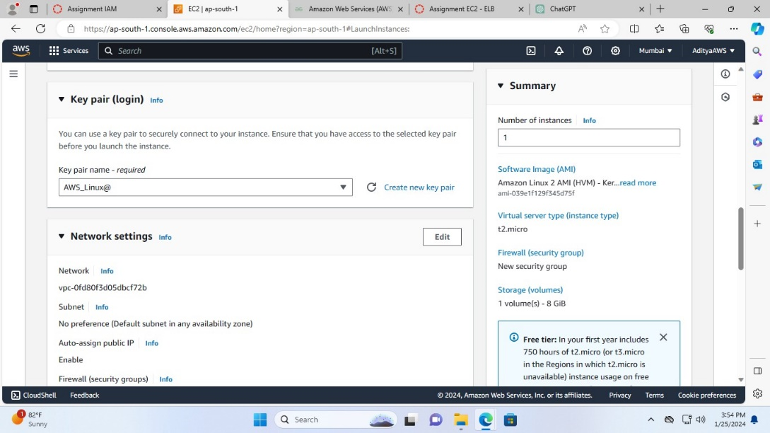

1. Now, in the network settings select create security group and tick to allow the traffic.

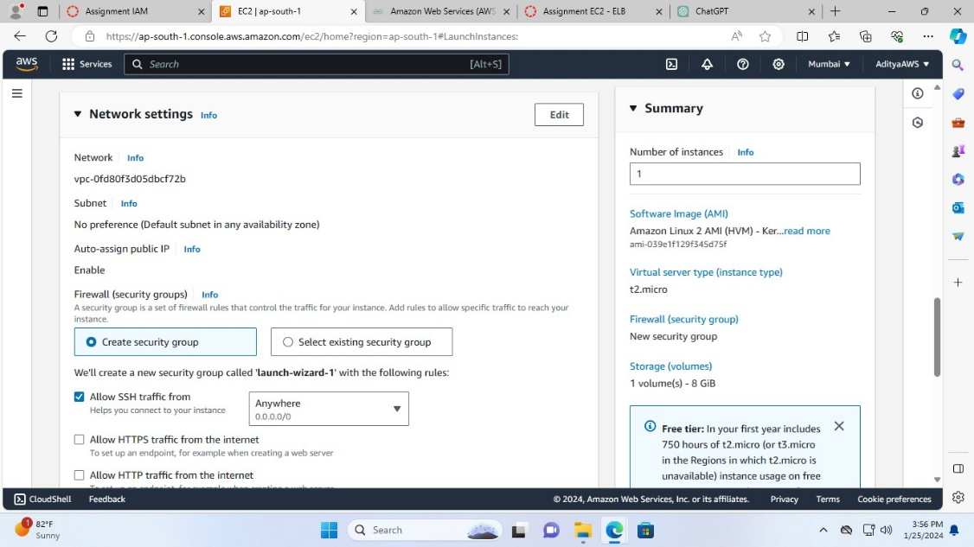

1. Leave everything as it is and click on Launch instance.

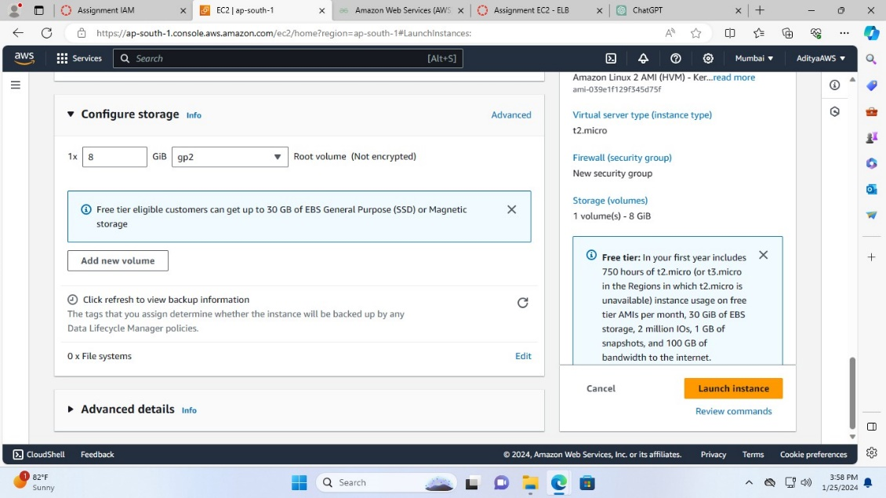

You can see that the launch of instance is initiated successfully.

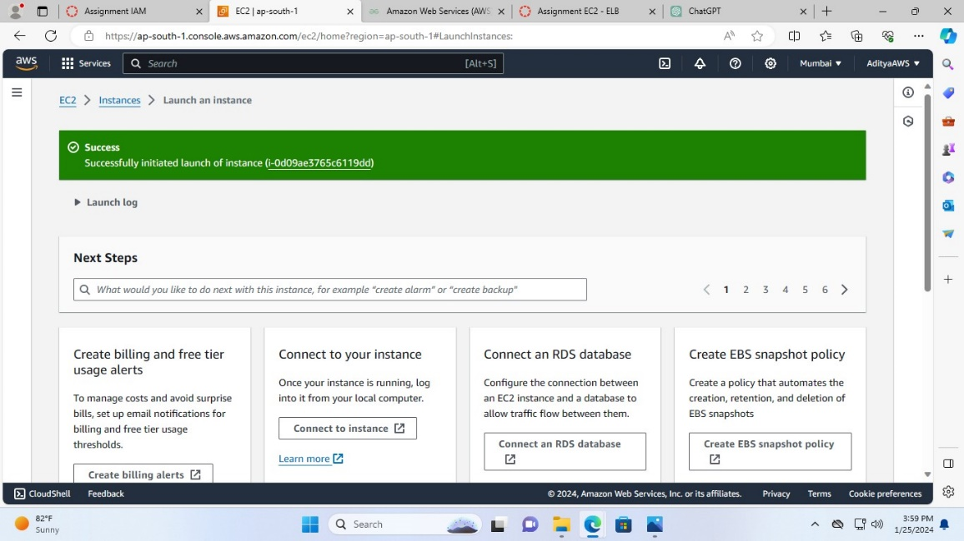

**Now, to configure security group with 22 and 80 ports open.**

1. Edit the inbound rules of the security group (launch-wizard-1) of the instance launched and save the changes.

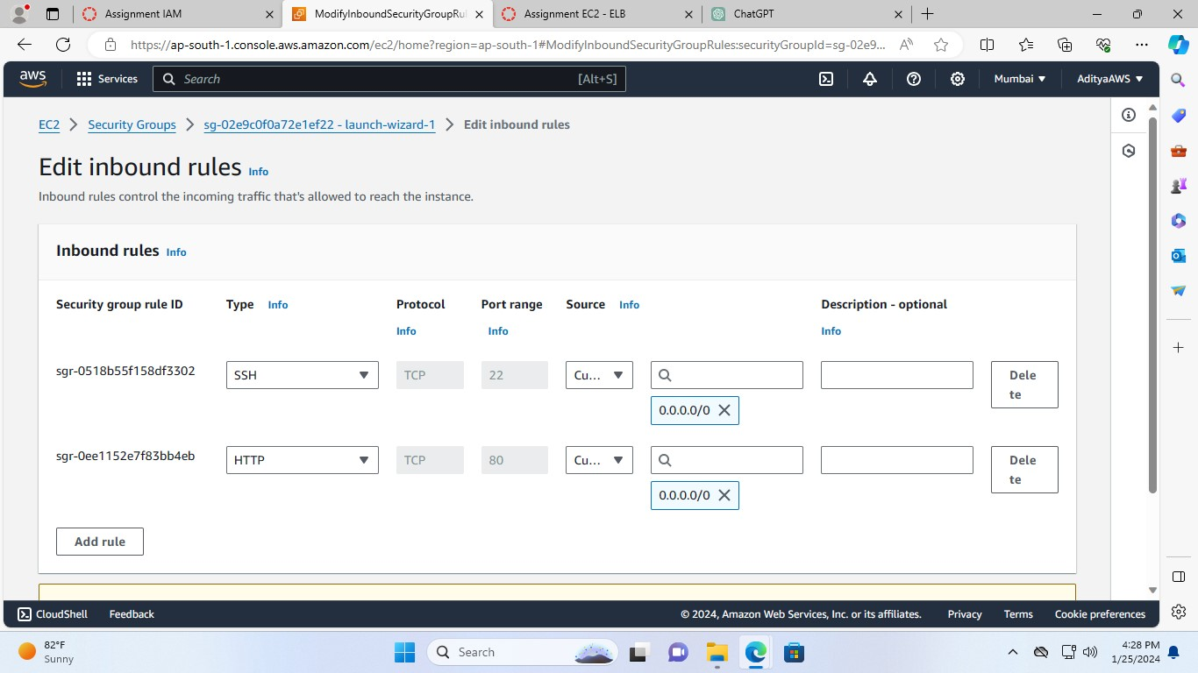

1. Now, it is configured with 22 and 80 ports open.

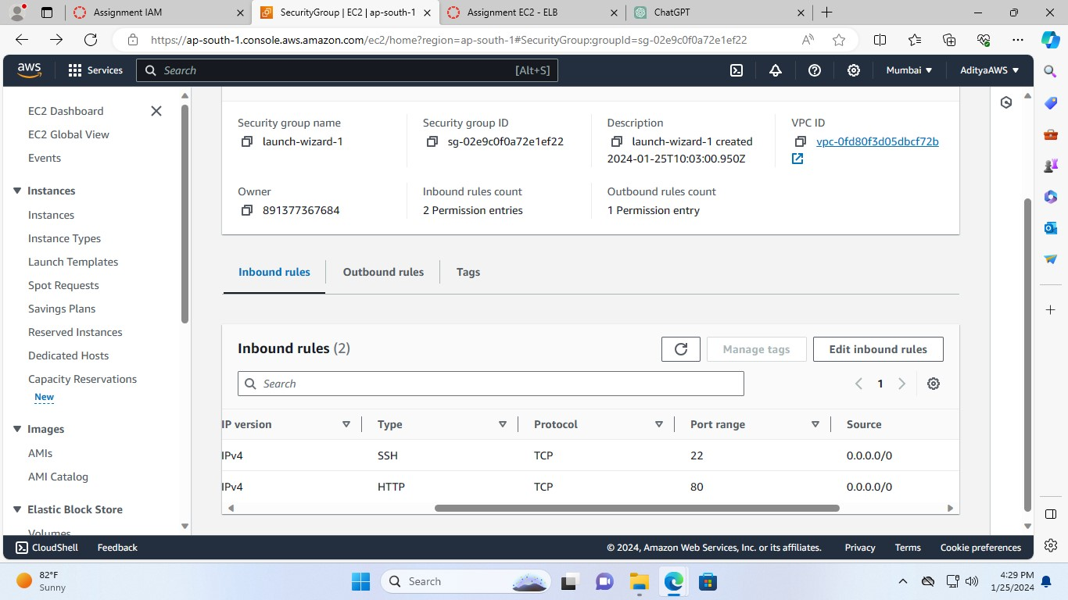

**In order to connect to the newly launched EC2 instance using SSH.**

1. Check for the .pem file in the directory in which you have saved the file.

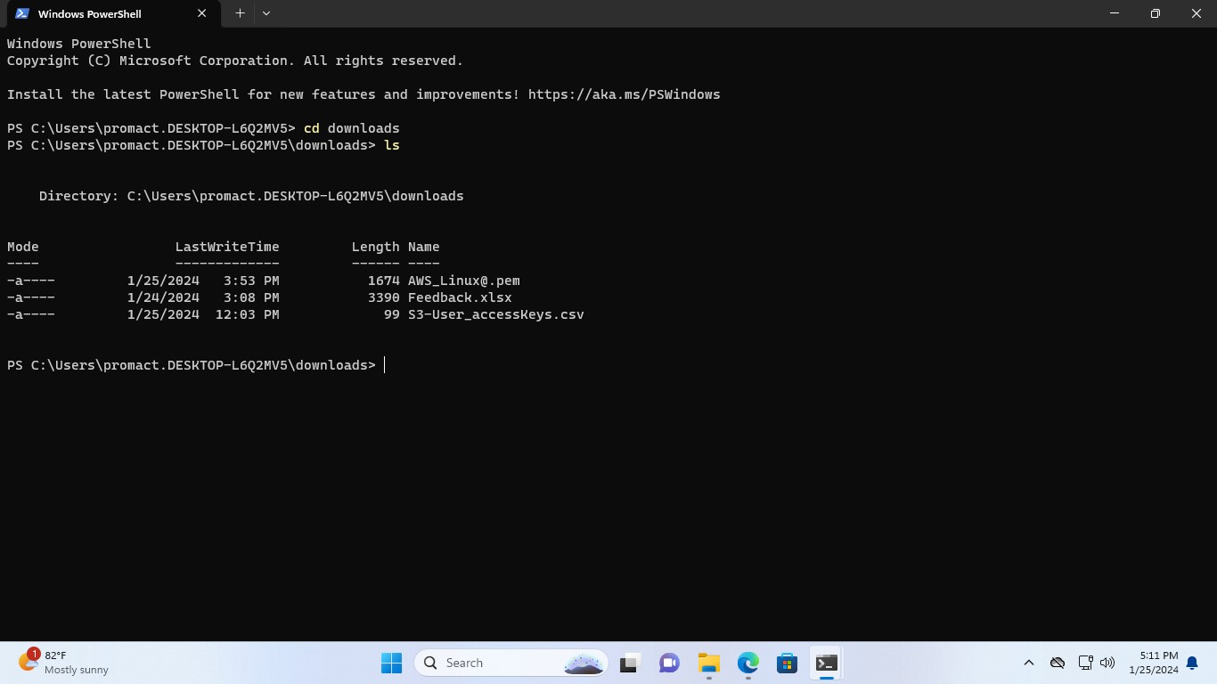

1. Then, run the command ssh -i .\AWS_Linux@.pem [ec2-user@65.0.72.215](mailto:ec2-user@65.0.72.215). Now you can see that the connection has been established.

